Affordable drone platform for use in education

September 10, 2016

Authors: Sundaramahalingam Sudharshan, Isaac Tay Eng Hian, Ambrose Chua, Prahlad Vadekkepat

# Introduction

The drone industry has seen a market growth from a 552 million USD industry in 2014, to 1.4 billion USD in 2015 with an expected forecast of 5 billion USD in 2017.[1] Research papers have been published on applying drones to practical uses excluding recreation like agriculture, surveillance, security and industrial automation. One area of research is into its use as a military attack platform where the industry is estimated to hit 1.8 trillion by 2017.[2] Additionally, Unmanned Aerial Vehicles (UAVs) have high potential in the agriculture industry where they are being used to crop and monitor large plantations and vegetation.[3] More specialized applications like mosquito vector control[4] and oil spill detection monitoring[5] are also being investigated by researchers.

Similarly, the education industry is trying to integrate drones into the curriculum and research is being conducted into drones as a platform for robotics research and education.[6] Providing researchers and students with software and hardware platforms have allowed them to overcome superficial issues such as communication and focus on the more complicated aspects of their research and projects.[6] Drones can be used to teach students about robotics, control systems, embedded system engineering, artificial intelligence and systems engineering.[7] Additionally, they could be used to teach concepts like projectile motion in a more intuitive and hands-on manner to high school students.

Quadrotor helicopters or quadcopters are currently the most common drone platform available. They operate on the mechanics of 4 rotors spinning at varying velocities which allows the drone to achieve steering and thrust through a PID loop based control system. [8] Unfortunately, these quadcopters are unaffordable to buy in large enough quantities for integration into the curriculum. Some quadrotor platforms also have exposed rotors which raises safety concerns for use in high schools. Although many of these platforms provide free software APIs for users, they often keep their hardware closed-source making it hard for students to learn hardware based topics using these platforms.

The design of the SentiBot platform is intended to solve these issues. It utilizes a dual-propeller electronic ducted fan (EDF) with an enclosed frame in a coax-copter design. This design increases safety while decreasing cost and enables high modularity. It has 3D-printed frame design which allows easy hardware replication for researchers and students such that experimentation can be conducted with additional hardware. The platform has the Intel Edison System on a Chip (SoC) and a unique dual CPU architecture which enables compartmentalization of computational tasks. [9] The higher level tasks are managed by the Intel Edison CPU while the lower level real-time tasks are handled by the ATMEGA 328 8-bit microcontroller running a real time operating system (RTOS). The platform is running Yocto Linux and supports ROS which provides open source libraries and software resources for students and researchers. [10]

# Hardware Design

## Aspects of an educational drone

The current concern with drone safety has resulted in the increased regulation by governments on the usage of drones in the public and in multiple industries. [11] Thus, the safety of the drone is an important aspect to consider in the design. Affordability is also important as a lower cost drone platform allows a greater adoption rate by schools as it has a smaller impact on them financially. As budget cuts faced by schools is impacting adoption of drone based curriculum [12] it is important to ensure that the affordability aspect is not neglected. Robotics platforms used in education need to provide easy access to their hardware and software systems to enable the students to learn through experimentation according to research conducted into educational robotic systems.[13] Therefore, the aspects of an education drone platform can be summarized as safety, affordability and accessibility.

## Novel Frame design

The Sentibot uses a novel frame design which is made through additive material fabrication using a Nylon-6 filament. This is because Nylon-6 provides a high durability to weight ratio which is favorable for a flying platform.[14] The novelty of this design as compared to similar coax-copters is that the electronics are housed outside of the main body in contrast to the internal housing seen in other coax copters.[15] This enhances the accessibility of the electronics components for users.

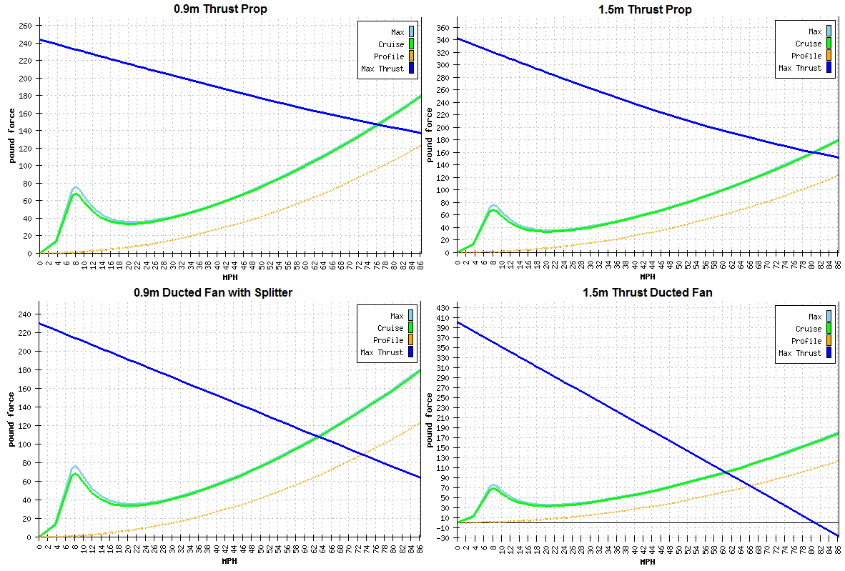Additionally, a modular frame design based on support beams is used and that holds the frame together. The compressive strength of cylinders has been shown to be superior of cuboids due to lack of discrete stress points like the corners of a cuboid [16], thus the frame is designed with a cylindrical form factor. A two part motor assembly is used to enclose 2 counter-rotating rotors which creates a ducting effect. This increases efficiency at high rotary speeds and also enhances the static thrust performance of the system. [17]

Figure 1: Thrust test comparison between propeller and ducted fan

Control and steering is accomplished through 4 thrust vectoring vanes manipulated by 3.3g 5v servos. This is typical of other coax-copters as well. [15] These vanes are housed within protective housing to minimize damage during collisions. The servos are housed internally with access panel doors to enable replacement of damaged components. The frame encloses all moving components and aids in increasing the safety of using this platform.

## Motor-Propeller combination

By spinning counter-rotating bullnose propellers using a 4000kV race quad motor, the SentiBot can achieve a high thrust to space ratio. Performance analysis of propellers show that larger diameter propellers are more efficient as compared to smaller propellers. [18] The SentiBot uses 2 large rotors arranged in a stacked configuration as compared to a quadrotor which uses 4 smaller propellers arranged in a plane thus higher efficiency can be obtained from the SentiBot.[18] This allows for a compact frame design while preserving the payload carrying capacity.

|  |  |  |  |  |  |  |  |
| --- | --- | --- | --- | --- | --- | --- | --- |
|  | No Load | | On Load | | | | Load Type |
| Voltage | Current | Speed | Current | Power | Pull | EEP | Battery/Prop |
| V | A | rpm | A | W | g | % |
| 11.1 |  |  | 1.8 | 20 | 80 | 4 | LiPoX3/T3030 |
| 4.3 | 47.7 | 160 | 3.4 |
| 7.7 | 85.5 | 247 | 2.9 |
| 14.8 | 0.9 | 5927 | 1.9 | 28.1 | 100 | 3.6 | LiPoX4/T3030 |
| 4.7 | 69.6 | 200 | 2.9 |
| 10.7 | 158.4 | 390 | 2.3 |

Table 1: Motor thrust test results from the manufacturer of the motors

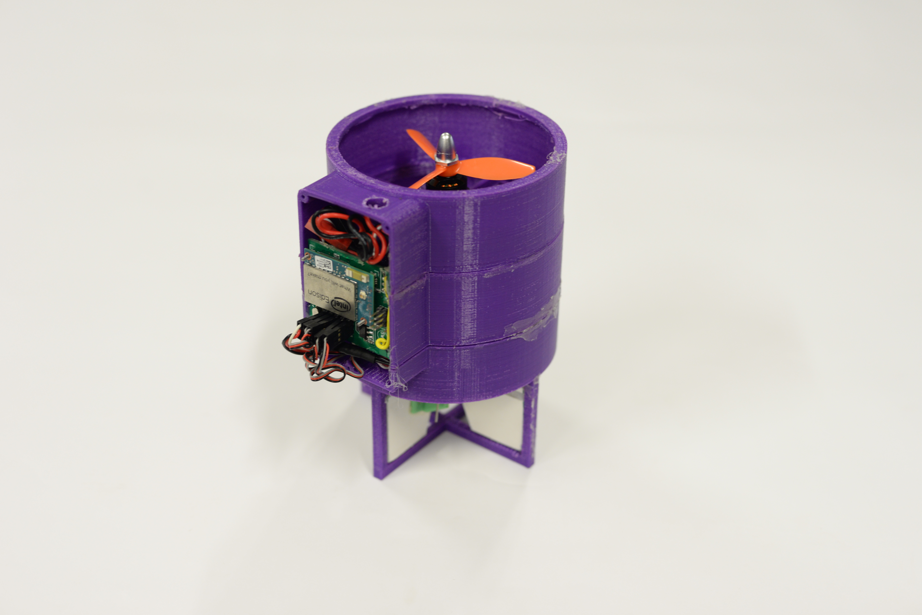 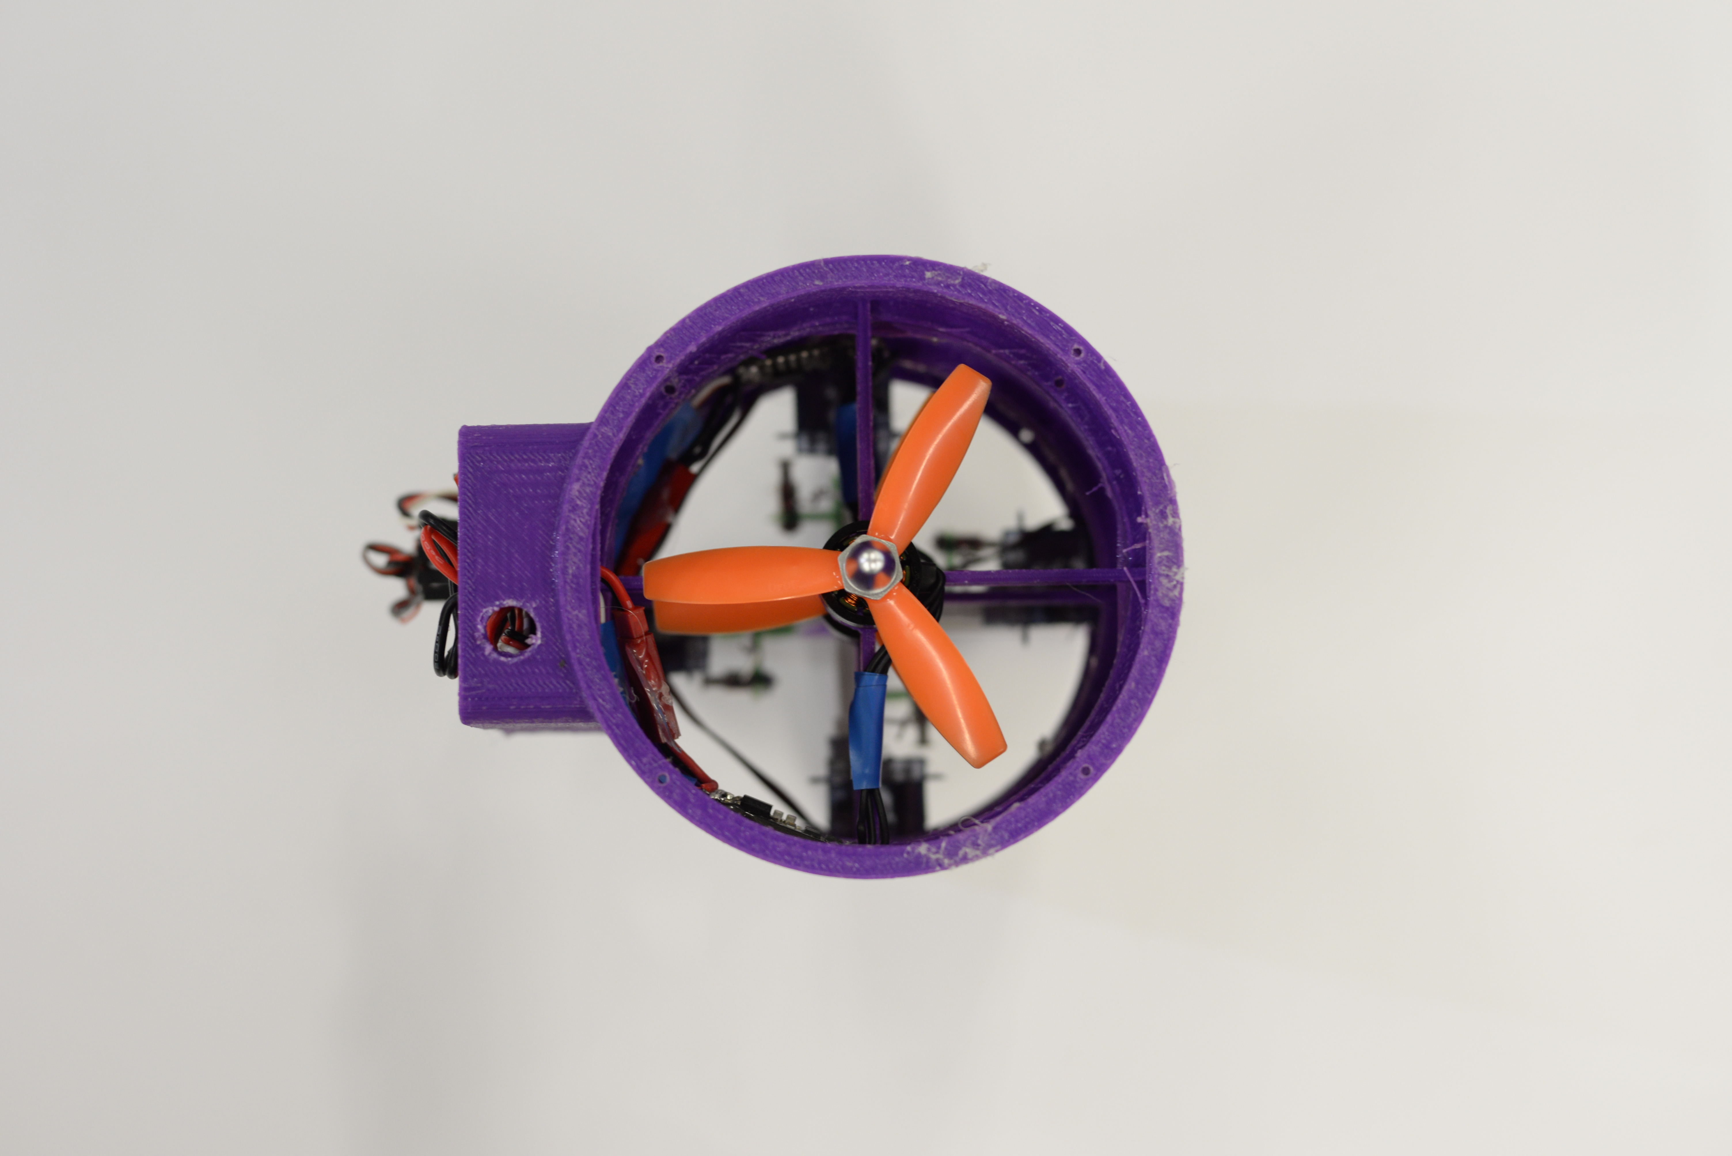

Figure 3: Image of the functional SentiBot platform (Top-Down view)

Figure 2: Image of the functional SentiBot platform (Perspective View)

# Electronics Design

## Main Processor

Table 2: Hardware components of the drone platform

|  |  |
| --- | --- |
| Main Processor | Atom 2-Core (Silvermont) @ 500 MHz |
| Secondary  Microcontroller | ATMEGA 328P |
| Motors | 4000KV Motors |
| ESCs | 12A XMS Series |
| Batteries | 800mAh, 4S (14.8V) |
| Propellers | 3x3x4.5in |
| Servos | 2.8g |
| Thrust | 500g |
| Weight | 250g |

Currently there is extensive research conducted into decentralized computing and swarm intelligence [19]. Thus, there is a need for a powerful onboard processor as computing power intensive tasks cannot be offloaded to a ground-station when such research is being conducted. Vision processing and autonomous navigation also are very computing intensive.[21] The SentiBot has an Intel Edison SoC which consists of a 500Mhz Intel Atom, an Intel Quark microcontroller (MCU), 1GB of onboard DDR3 RAM and 4GB of onboard flash storage.[22] This allows the platform to do many computing intensive tasks which students and researchers are expected to use.

## Dual CPU architecture

The Intel Edison is suitable for use as a microprocessor but cannot operate in real time which leaves it unable to generate control signals for servos and the motor. By using an additional ATMEGA 328 microcontroller, the platform gained additional sensor expandability options through getting more general purpose input-output pins (GPIO) and the ability to operate in a RTOS. A custom 2 layer PCB was designed to combine these 2 processors together to get a dual-CPU architecture. Tasks that more complex are executed in the processor while time-critical tasks like communication with sensors and actuators are done in the microcontroller. The separation of the higher and lower level processing also provides code organization in the software.

## On board sensors

The main sensor which allows for the drone to fly in a stable manner is the Inertial Measurement Unit (IMU). This sensor provides accelerometer and gyroscope information to the secondary processor for the PID loop to keep the drone upright. The sensor also allows for dead reckoning to be used for localization. [23]

The IR distance sensors mounted on all 4 sides allows for collision avoidance to prevent crashes. There is also an onboard RGB camera which interfaces to the primary processor over USB.

## Flight Drive system specifications

The power electronics consists of 4 1C 1200mAh batteries, 2 30A super light ESC’s and 2 4000kV 1306 motors. The motors have a max current draw of 8A each and taking into consideration that the max thrust of each motor is 370g the gram per current rating for each motor is 46g/A. Since the weight of the SentiBot is about 320g, the nominal current draw during a hover would be about 7A. That gives a flight time of about 10-15 minutes.

## Power Supply management

In terms of power management, 3 voltage levels are required- 14.8V from the battery, 5V for the control board and 3.3V for the control circuity. Since the drone’s ESCs do not come equipped with a built in battery eliminator circuit (BEC) an external switching regulator is used to supply clean 5V for the control board. The onboard 3.3V LDO further steps down the voltage from 5V to 3.3V.

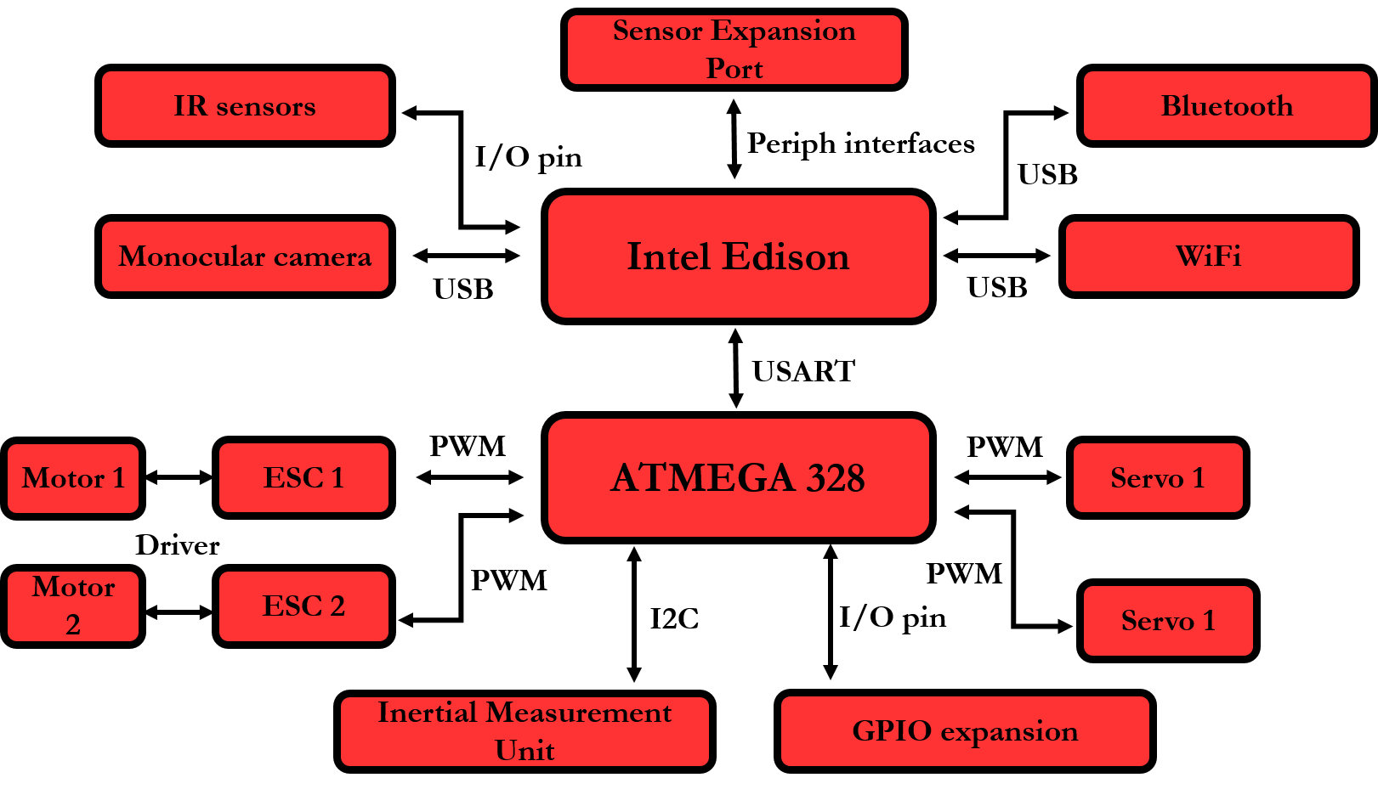

Figure 4: Hardware peripheral wire-up diagram in the SentiBot

# Software Design

Good hardware needs to come with good software. By ensuring modularity and modifiability, the platform will be education-friendly. SentiBots has two methods of operation: manual and autonomous. In manual, an operator has full control and information from the drone. Operated autonomously, the drone is user-programed to complete tasks with little or no human intervention.

~~An important aspect of creating a student friendly drone platform would to be provide modular and easily modified software. There are primarily 2 ways this drone can be operated. The first way is the manual mode, where the drone is flown by an operator manually and information is streamed down from the drone to the ground-station for analysis. This makes the SentiBot act as an Unmanned Aerial Vehicle (UAV) with manual control. Another way this drone can be operated is in the fully autonomous mode. In this mode, the drone is able to make intelligent decisions to achieve a certain task on its own.~~

SentiBots has two subsystems: control and intelligence. The control subsystem consists of the hardware interface to GPIO and the IMU, and relevant PID loops. It also can provide basic obstacle avoidance.

The intelligence subsystem is for complex tasks like navigation, localization, vision, object identification and other tasks for autonomous flight. It also provides communication with the groundstation.

~~There are also mainly 2 main subsystems in the software. The first subsystem is the lower level processing which encompasses the control loop to stabilize the drone, the GPIO management, the IMU reading and writing, and some low level sensor reading and obstacle avoidance. This subsystem is intended to run in the ATMEGA 328.~~

~~The second subsystem is the higher level subsystem. This higher level subsystems encompasses the more complex tasks like navigation, localization, vision algorithms, object identification and other essential tasks for autonomous flight. This system also manages communications infrastructure between the drone and the ground station and acts as a relay between the ground-station and the lower level subsystem.~~

## Lower level subsystem

### PID Loop

The control algorithm in SentiBot is standard. Sensor data is mapped into error values that can be used to compensate for frame errors and instabilities. IMU data (processed by an internal DSP) is read over I2C to obtain yaw-pitch-roll (ypr) data. Each ypr value is used in PID loops for each axis to obtain error values. The angle of the control surfaces are set by the error values, therefore stabilizing the system. This computation runs on the ATMEGA 328. ~~Implementing the classic PID control loop, we allow the sensor data to be mapped into error values that can be used to compensate for frame errors and instabilities in the frame. The control algorithm first reads the I2C bus and outputs the data from the IMU which has been preprocessed by the Digital Signal Processor (DSP) on board the IMU. This allows for the control algorithm to get filtered and processed yaw-pitch-roll (~~**~~ypr~~**~~) data for use in the PID algorithm.~~

~~The processed~~ **~~ypr~~** ~~values are sent through the respective PID loops for their specific axis and used to obtain 3 error values for each of the x, y and z axis. These error values can then be used to output to the servos, which then tries to bring the system back to the stable state by moving the specific servos. The barometer also enables altitude hold using another PID loop. All of the control algorithm runs onboard the ATMEGA 328.~~

### Communication Infrastructure

As shown in *Figure 3,* A I2C peripheral interface is used between the lower level subsystem and the Inertial Measurement Unit (IMU). A USART interface is used between the microcontroller and the processor running the higher level subsystem. This communication is managed by software that utilizes the Multi-Wii protocol. [5]

### Multi-Wii firmware

The firmware which runs the lower level subsystem is based on the open-source Multi-Wii project. Minor modifications were made to the firmware for coax-copter support but the built-in Multi-Wii PID loop controller and communication infrastructure were used. The open-source Multi-Wii framework is modular and easy to modify for the end user. The Multi-Wii platform is also well documented and easy to understand.

### Collision Avoidance

The lower level subsystem carries out basic collision avoidance system with 4 IR sensors installed around the bot. This prevents higher level algorithms from allowing crashes and damage to the bot and the environment. This is done through a modification that is made to the Multi-Wii framework which adds collision avoidance functionality to it.

## Higher Level subsystem

The higher level subsystem runs communication infrastructure with the groundstation and the autonomous system. The higher level subsystem runs on the processor which has onboard WiFi and Bluetooth.

### Autonomous infrastructure

The autonomy of the SentiBots, when implemented in a fully modular manner, allows students to tap onto resources available online and libraries for implementing autonomy in the SentiBots. Thus, the SentiBots is based on the ROS architecture which is completely open source and provides existing libraries for students to easily implement systems into the robots. The ROS architecture is already used by students and researchers.

### Communication setup

The communication system is reliant on the onboard WiFi chipset present in the Intel Edison SoC. It connects to an 802.11n network operated by the ground station and transmits over the established network. It also transmits telemetry information gathered from hardware through the microcontroller and sensor expansion port.

## screenshot_2016-03-07-20-10-03_ioGround-station software

We are currently still in the process of designing and implementing the ground-station. However, we have developed a rudimentary control method by an Android app. It transmits UDP frames over the network to the processor via 802.11n which allows instructions to be issued to the SentiBot. A Spektrum satellite receiver has also been added to the spare UART2 port for longer range and lower latency to test the hardware.

Figure 5: Screenshot of the android app

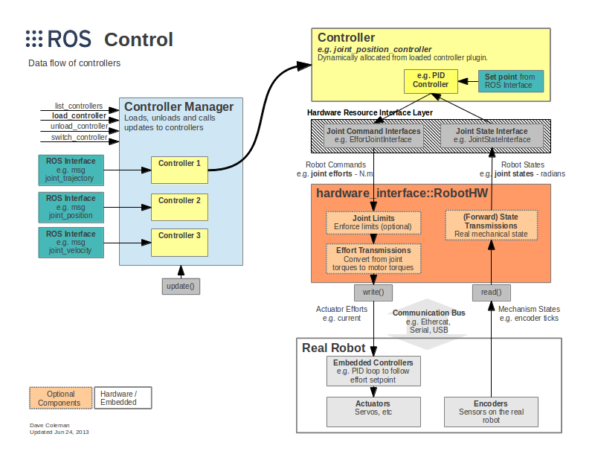

Figure 6: Standard ROS based architecture [6]

# Results

The results of initial testing were positive. The SentiBot shows the ability to lift off, and fly in a stable hover with minimal user intervention. When moved around, the SentiBot platform can accurately maintain its attitude without much user compensation. Currently, the SentiBot is manually controlled but research is underway to demonstrate its autonomous functionality. Furthermore, the drop tests were significantly positive showing that the SentiBot can survive drops from up to 3m high due to its rigid 3D printed PLA frame. These drop tests were conducted through flying to robot up to a certain height and removing power from the motors and measuring how high we could drop from before there was damage to the frame. Only one test run was conducted. In testing, the top speed achieved from the SentiBot is also about 20km/h and flight times are about 15 minutes with normal flying. Furthermore, the SentiBot is able to achieve versatile flight through, under and over several obstacles without any problems due to its small size and form factor. The SentiBot can also easily take collisions with walls or other obstacles without falling due to its shell.

Figure 7: Comparison between SentiBots and similar platforms]

# Conclusion

The SentiBot project set out to bring an extremely safe, easy to use and cheap drone for use in educational institutions around the world. It aimed to solve some critical issues in bringing consumer drones to educational institutions for use in student interaction and learning processes by making an ideal drone platform that caters to the cost, ease of use and safety issues presented in those consumer drones. We have created that platform in SentiBots. The competitive pricing with consumer drones while providing one the safest and most hackable drones in the world today makes it highly suitable for educational institutions ranging from secondary schools to tertiary institutions and universities.

Some future work could be conducted into more detailed software which can complement the SentiBot hardware platform as software support for coax-copters in the world today is very limited and rudimentary.

# References

[1]- Droneii.com. (2016). [online] Available at: https://www.droneii.com/wp-content/uploads/2016/01/top20-early-stage-drone-start-up-fundings-1024x769.png [Accessed 9 Oct. 2016].

[2]- Amenyo, John-Thones, et al. "MedizDroids Project: Ultra-low cost, low-altitude, affordable and sustainable UAV multicopter drones for mosquito vector control in malaria disease management." *Global Humanitarian Technology Conference (GHTC), 2014 IEEE*. IEEE, 2014.

[3]- Aznar, F., Sempere, M., Pujol, M., Rizo, R., & Pujol, M. J. (2014, March). 201. 4. Hindawi Publishing Corporation.

[4]- Phys.org. (2011). *Japanese inventor develops flying sphere drone*. [online] Available at: http://phys.org/news/2011-08-japanese-inventor-sphere-drone.html [Accessed 9 Oct. 2016].

[5]- GitHub. (n.d.). *MultiWii*. [online] Available at: https://github.com/multiwii [Accessed 9 Oct. 2016].

[6]- Wiki.ros.org. (n.d.). *ros\_control - ROS Wiki*. [online] Available at: http://wiki.ros.org/ros\_control [Accessed 9 Oct. 2016].

[7]- Jamaluddin, Musa. "Flying Robot Surveyor (To Build FRS Hardware and Remote Control Design with IP Camera)." (2013).

[8]- Uyar, Ekrem Bilgehan, İsmail Uyanık, and Ömer Morgül. "Implementation and Control of an Open Source Quadrotor Platform."

Green, Miranda. "Unmanned Drones May Have Their Greatest Impact on Agriculture." *Daily Beast* (2013).

Kreps, Sarah, and Micah Zenko. "Next Drone Wars; Preparing for Proliferation, The." *Foreign Aff.* 93 (2014):

http://link.springer.com/book/10.1007%2F978-3-319-23760-2

Luukkonen, Teppo. "Modelling and control of quadcopter." *Independent research project in applied mathematics, Espoo* (2011).

Pedretti, D., et al. "CUSTOM HARDWARE PLATFORM BASED ON INTEL EDISON MODULE." (2015).

<http://www.cbpp.org/research/state-budget-and-tax/most-states-have-cut-school-funding-and-some-continue-cutting>

Mataric, Maja J., Nathan P. Koenig, and David Feil-Seifer. "Materials for Enabling Hands-On Robotics and STEM Education." *AAAI spring symposium: Semantic scientific knowledge integration*. 2007.

Evans, Brian. Practical 3D printers: The science and art of 3D printing. Apress, 2012.

Del Viso, J. R., J. R. Carmona, and G. Ruiz. "Size and Shape Effects on the Compressive Strength of High Strength Concrete." *6th International Conference on Fracture Mechanics of Concrete and Concrete Structures*. 2007.

Mort, Kenneth W., and Paul F. Yaggy. *Aerodynamic characteristics of a 4-foot-diameter ducted fan mounted on the tip of a semispan wing*. No. NASA-TN-D-1301. NATIONAL AERONAUTICS AND SPACE ADMINISTRATION MOFFETT FIELD CA AMES RESEARCHCENTER, 1962.

<https://www.google.com.sg/url?sa=i&rct=j&q=&esrc=s&source=images&cd=&cad=rja&uact=8&ved=0ahUKEwj9i8WPv9fPAhXEt48KHff3Dj0QjRwIBw&url=http%3A%2F%2Fhoverclub.org.uk%2Findex.php%3Ftopic%3D5193.0&psig=AFQjCNHlErXnxYmNo0Wv7baqRmGHOEUb0w&ust=1476438209927858>

Merchant, Monal P., and L. Scott Miller. "Propeller performance measurement for low Reynolds number UAV applications." *AIAA* 1127 (2006): 2006.

Ma'sum, M. Anwar, et al. "Autonomous quadcopter swarm robots for object localization and tracking." *Micro-NanoMechatronics and Human Science (MHS), 2013 International Symposium on*. IEEE, 2013.

Bertozzi, Massimo, Alberto Broggi, and Alessandra Fascioli. "Vision-based intelligent vehicles: State of the art and perspectives." *Robotics and Autonomous systems* 32.1 (2000): 1-16.

<http://download.intel.com/support/edison/sb/edison_pb_331179002.pdf>

Kleeman, Lindsay. "Optimal estimation of position and heading for mobile robots using ultrasonic beacons and dead-reckoning." *Robotics and Automation, 1992. Proceedings., 1992 IEEE International Conference on*. IEEE, 1992.